NJKARAOKE.COM - Rental unit instructions
We suggest you set the unit up ahead of time and familiarize your self with how it works. If you have a question, most times you can reach Joe on his cell phone.

Joe (973) 980-8775

These are the supplies you will receive with the Karaoke Rental rig. There will be a large box with the amp and CAVS unit. There are 2 speakers, 2 wireless microphones, a TV, a box with wires and song books. | 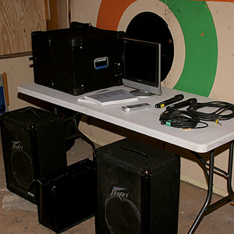
To get started, you will need to set the main box on a sturdy table or stand and remove the front and back covers. These are either snaps or twist locks, depending on the box. | 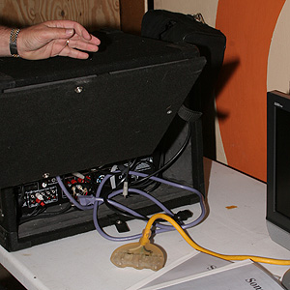
There is a power cable inside the box. The units inside are plugged into that and you will need to plug that into an outlet or heavy extension cord. | 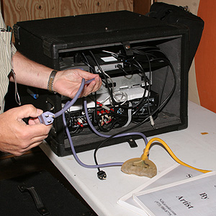
You will need to set the TV where it can be seen by your singers. The song lyrics will appear on it. It will need to be plugged in and you will need to connect the “RCA” style video to the video on the TV. This is usually a yellow receptacle, although the TV may be a little different than the picture. | 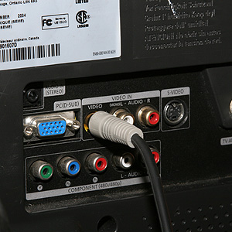
Find the two heavy speaker wires in the box (or bag) of cables. These can be plugged into the speaker outputs on the outside of the main units box (back corner) as show. | 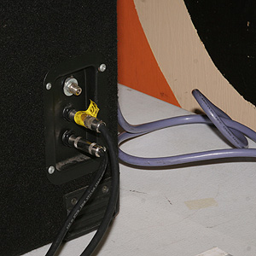
The other end of the wires plug into the back of the speakers. The speakers should be up off the floor so the sound is ‘aimed’ toward the listeners. | 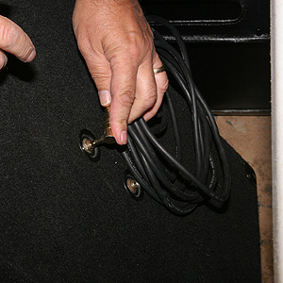
Before you power anything up, make sure the volume is turned down on the amplifier (bottom unit in the box).  We ask that you turn it down to zero before returning the machine. | 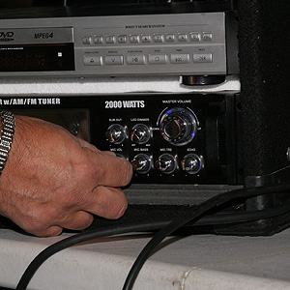
Start by turning the amplifier on. This button is on the left side of the bottom unit. Make sure the TV is turned on, as well.  Make sure the display (above the numbers) shows DVD/CD. The “input” button will cycle through the options. | 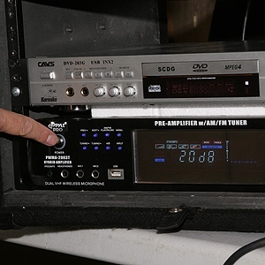
Your wireless microphones have a trap door at the bottom and take a 9 volt battery. We put new batteries in the before they go out, but you will find extra batteries in the cable box/bag. | 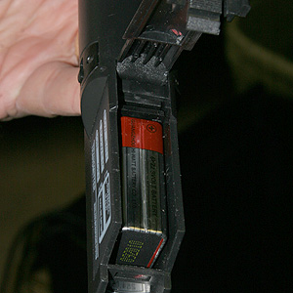
The microphones also have an on/off switch. Make sure they are turned on. | 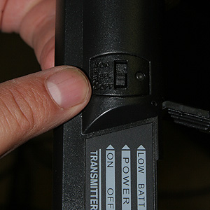
Next turn on the CAVS unit. In the picture, this is the silver unit on top. On some rigs, it’s in a black case, but either way, it will say CAVS on it. | 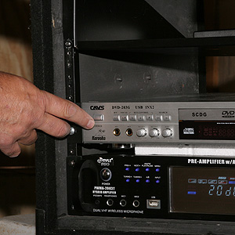
When the CAVS unit is powered on, press the fist button next to the power button. This is marked DU. This will tell the unit to look for the external hard drive for the songs. | 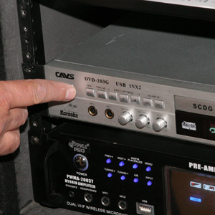
The unit will come up and say “Initializing.” on the TV. This process may take about a minute.  IF IT TAKES LESS THAN 30 SECONDS TO GET TO THE CAVS SCREEN: This usually means the USB connector on the hard drive has shifted during transit. At the back of the box, locate the hard drive (a metal box about the size of a book. Follow the cable into the CAVS unit and gently remove the plug. They plug it back into the same receptacle. This reseats the plug. Now go back to the previous instruction, power off the CAVS unit - wait a few second and turn the power back on. | 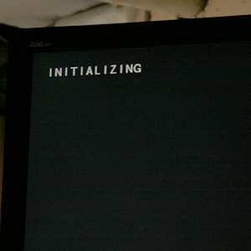
The unit will come on the CAVS logo. | 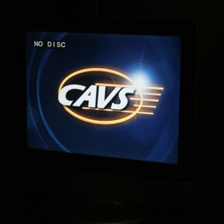
This will be followed by a selection for DVD or USB DEVice. We are using USB. | 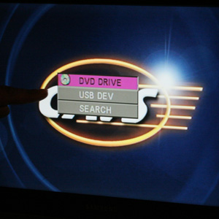
Use the CAVs remote to select USB (with arrows) and press enter. REMEMBER – aim the remote at the CAVS unit in the box, NOT the TV! | 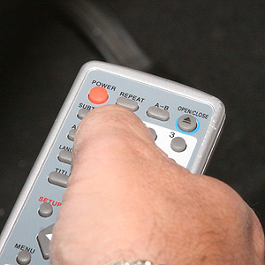
This will bring up the USB menu. We are going to select the USB 16184 device at the bottom of the list. | 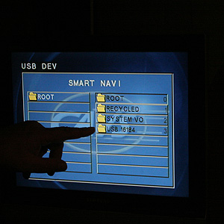
Use the arrows on the remote to make this selection and then press enter. | 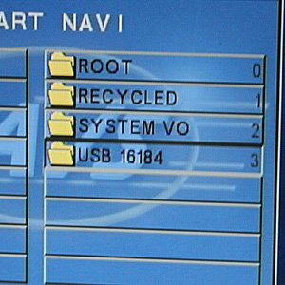
This will bring up the Karaoke menu | 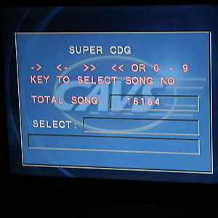
Grab one of the song books to select a song. One book is songs by title, the other is song by artists. These can also be downloaded from our website as a pdf file, if you wish a preview. | 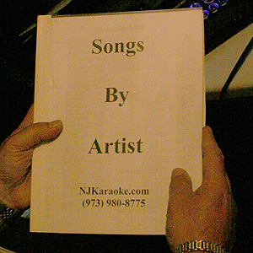
Find the song you want and the associated number. Some songs have leading “0” before the number. You don’t need this, but it won’t hurt anything either. | 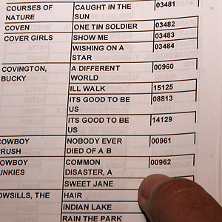
Point the remote at the CAVS unit and enter the number.

Note – the 0 button is offset so sometimes people don’t notice. If you hit the wrong button in place of the ‘0’ you will get back to the DVD/USB DEV menu step above.
As you enter the number, the corresponding song title will come up (it my change as you enter numbers, but before the complete number is enter – don’t worry – keep going!)  When the song you want is shown, hit enter on the remote to start. | 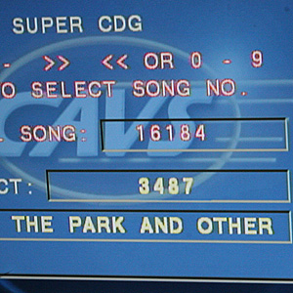
The words to the song will come up with any other information you might need (like “15 seconds music only introduction” or something like that). | 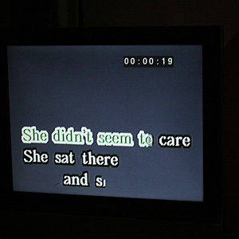
When the song is done, the unit will return to the selection menu. Simply select another song to continue.
OPTION: If you’d like to hook an IPOD or MP3 Player for background music, you can run it though out system. All you need to do is plug it in. There are a variety of cables and plugs in the cable box/bag that should work for most units. Find the on that fits your particular Ipod/MP3 player. The cable shown can be used for most players by connecting to the headphone jack. | 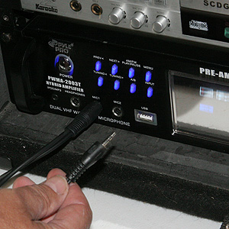
If you plugged into the receptacle at the far left (labeled IPOD) you will need to set the input to “IPOD/MP3.” If you plugged into the MIC jack with the adapter (as shown above), you need to select MIC. Again, use the “input” button to cycle through the options. | 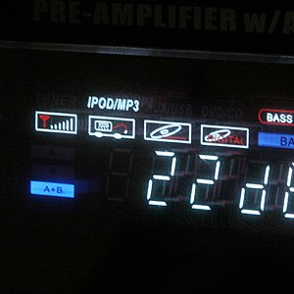
To return the units:

* Make sure the amp volumes are set to zero,
* Shut the units off at the power switch.
* Turn the microphones to off.
* Unplug the cables and return them to the cable bag/box, along
with the song books and microphones.
* Unplug the power and TV.
* Put the box covers back into place (Snap on or twist lock)

